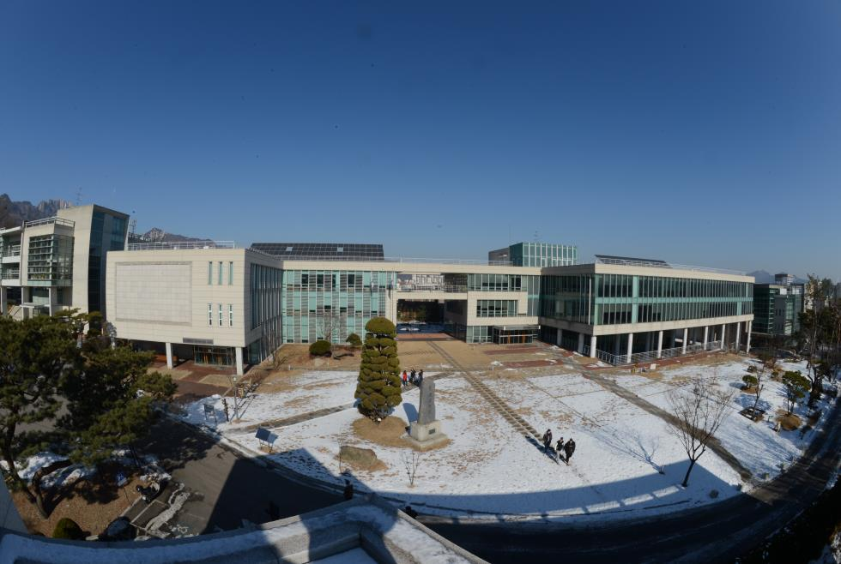

Studies in Ecumenism & Social Transformation
(S.E.S.T.)
Graduate School of Theology
Hanshin University

The Academic Year of 2026-2028
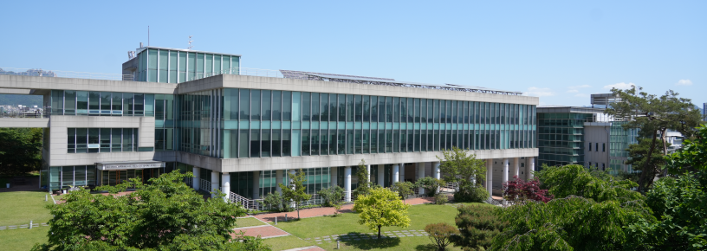
❙ Message from the President

“May the grace of our Lord Jesus Christ lead all of our lives to peace and justice”
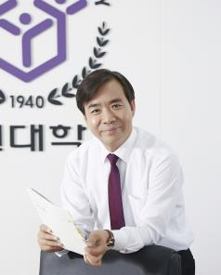
The world we live in faces a worsening crisis with each passing day. Economic globalization, escalating religious and ideological conflicts, and a global pandemic have led to the rise of global poverty and widening of inequality. Terrorism and war have led refugees to flee from their homes. Conflicts between generations and nations grow more severe each day. In this context, the confession of Jesus as the Lord of Peace and Justice became a prophetic act, calling for more concrete and courageous decision.
The program of ‘Studies in Ecumenism and Social Transformation (S.E.S.T.)’ at Hanshin University aims to awaken the churches worldwide to take responsible action to reform such a world and to train Christian leaders who will make a difference. The program is designed for students to acquire an effective leadership for solidarity in domestic and international levels.
All the members of Hanshin community welcome you, from all over the world, with our heart. We will embrace you in one faith, one hope and one love. I firmly believe that your experience of learning, sharing and practices in the S.E.S.T. program will empower you to become a leader who will transform this world for a better future.

Rev. Dr. Kang, Sung-Young
President
Hanshin University

❙ Message from the Dean

“A Cradle of Asian Contextual Theology and Social Spirituality”
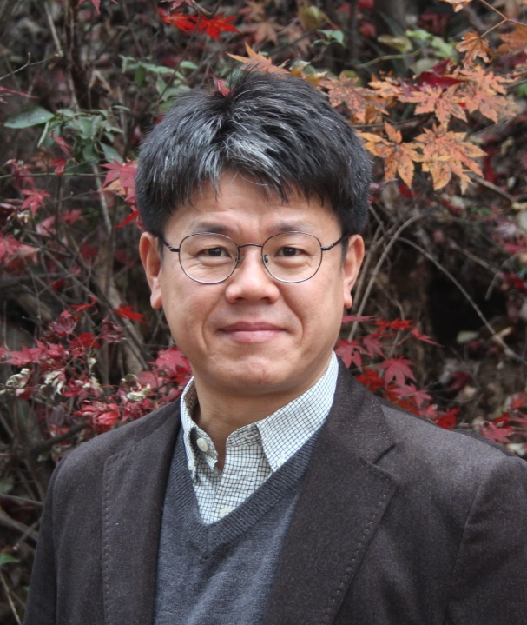
The Graduate School of Theology at Hanshin University, recognized as the birthplace of Korean minjung theology, carries a distinguished legacy of transformative ecumenism and a forward-looking vision for nurturing future ecumenical leaders. Since 2012, the SEST program has been uniquely designed for students who discern a vocation toward social and ecclesial transformation within the ecumenical tradition. This two-year Master’s program, offered with full tuition support, welcomes dedicated and dynamic students from Asia and across the globe. We invite you to embark on this inspiring journey with us.

Rev. Dr. Kim, Hiheon
Dean of the Graduate School of Theology
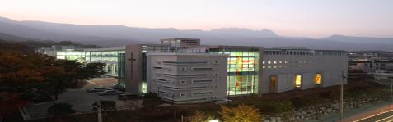
Envisioning ecumenism, articulating prophetic spirituality

Studies in Ecumenism & Social Transformation
The Graduate School of Theology
Hanshin University

❙ Brief History of Hanshin University

Hanshin University had its beginnings as the Chosun Theological Seminary, founded in 1940 and originally located in Seungdong Church in Insadong, Seoul. In 1951 the name of the Seminary was changed to Hankook Theological Seminary. Since its inception, the seminary has emphasized the core educational values of freedom of learning and freedom of conscience, veering away from dogmatism and authoritarianism. Due to the growing need for well-educated persons for the Christian Ministry in the local churches of the Presbyterian Church in the Republic of Korea (PROK), a new campus site in Suyu-ri was acquired to accommodate the growing number of enrollees.

The prophetic witness of the churches in society was growing in the midst of militarization and despotic political hegemony in 1970s and 1980s. Amidst the struggle for democratization and freedom, the need for strengthened educational institution emerged out of the fervent hopes and arduous labors of the church leaders and the school administrators. A crucial decision to expand the seminary into a full-blown university made it possible to purchase the campus site in Osan City.

Hankook Theological Seminary acquired its university status in 1979, with the sustained financial and moral support by the PROK churches, individuals and overseas partners. New buildings, such as dormitories, lecture halls, laboratories, chapels, cafeteria and other facilities were constructed to make the university one of the best learning institutions in Republic of Korea. In 1997 the government Ministry of Education selected Hanshin University as one of the leading higher educational institution in the country alongside other top notch universities.

The foundation of the Hanshin University was laid by Elder Kim Dae Hyun, Rev. Song Chang Keun, and Rev. Kim Chai Choon. It has produced some of most renowned church leaders and activists who have left their indelible marks on Korea’s modern history with personages like Chang Chun Ha, a prominent leader for democracy, and Rev. Moon Ik Hwan, a revered pro-unification activist. The tradition is still alive in the Graduate School of Theology. It continues to develop its academic and practical programs to nurture students in pursuing peace and justice and making a commitment to change the society in accordance with Christian values and hopes.

Hanshin University has more than five thousand students in both campuses, in Osan city and Seoul, as of 2025. About two hundred students are currently enrolled in the Graduate School of Theology. The English-based academic program (Th. M.) of the Graduate School of Theology, Studies in Ecumenism and Social Transformation (S.E.S.T.), had been launched in the year of 2012.
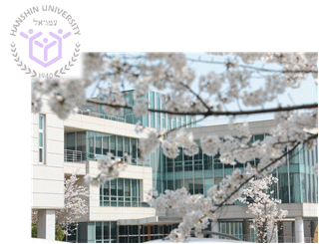
Organization of Graduate School of Theology

Administration Office (2125-0114)
∙ General academic affairs
∙ Help desk
 |  | Graduate School of Social Innovation Business |  |  | International Academic Affairs (2125-0108)  ∙ Management of foreign students  ∙ Academic affairs for S.E.S.T.  ∙ Help desk
 |  | Graduate School  of Human Care |  |  | Field Education Office (2125-0106)  ∙ Management of Chapel and Minister Cadet  ∙ Field Education Support
Hanshin University |  | Graduate School  of Theology |  |  | Jang-Gong Library (2125-0131)  ∙ Lend books & audiovisual materials  ∙ Reading room
 |  | Graduate School(Seoul) |  |  | Dormitory (2125-0110)  ∙ Boarder's managing  ∙ Gym & common kitchen
The World & Mission (2125-0106)
∙ Publication of school journal
Center for Lifelong Learning
(2125-0127)
 |  | 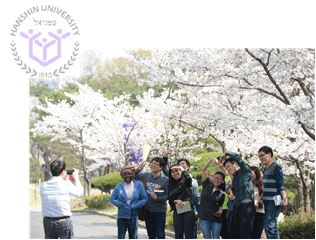 |  |  | Center for Religion and Science  (2125-0171)

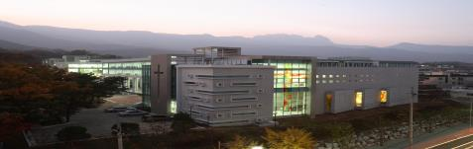
Studies in Ecumenism & Social Transformation
The Graduate School of Theology
Hanshin University
Seoul, Republic of Korea

❙ Goals

• To foster young people and adults in developing relevant and effective ecumenical leadership at both domestic and international levels.
• To facilitate a community-oriented and socially transformative learning process that promotes cross-cultural understandings and ecumenical spirit.
• To strengthen a network of ecumenical leaders who are guided by transformative religious and social ethics, and committed to building a society founded on peace and justice.

❙ General Introduction for the Program

• The program leads to Master of Theology (Th. M.) degree, which will be granted to students who complete the course requirements prescribed by Hanshin University.
• The curriculum is designed to balance two main areas: two-thirds of courses are related to ecumenical studies, while one-third is focuses to social transformation.
• The curriculum is designed to connect theory and practice. Through practical classes, this program aims to correlate theological and social issues with the actual life situations encountered by people, integrate actual learning experiences into the essential theological and ecumenical understanding, and formulate coherent theological statements aligned to Christian ethical values.
• English will be the primary language of instruction and English efficiency will be assessed through interview.
• The primary language for this program will be English. Around 90% of the courses will be taught in English. However, Hanshin University will offer Korean language class which will be needed to interact with the local church and community.
• The program spans two years, or the equivalent of four semesters. To complete the program, students are required to obtain 42 credits: 27 credits of seminar courses, 6 credits of thesis, 2 credits of field education/chapel and 4 credits of Guided Study and 3 credits of Korean language class.

Curriculum for the Academic Year of 2026-2027

 |  |  | S.E.S.T. Curriculum
1st semester |  |  |  |  | 2nd semester
Category |  | Subject name |  | Credits | Category |  | Subject name |  | Credits
Basic |  | Guided Study 1 |  | 2 | Basic |  | Guided Study 2 |  | 2
Practice |  | Field Education |  | 1 | Practice |  | Field Education |  | 1
Theology  subject | Bible | Biblical Theology |  | 3 | Theology  subject | Bible | Bible and Society |  | 3
Theology  subject | Bible | Contextual Readings of  the Bible |  | 3 | Theology  subject | Bible | Scriptural & Theological Reflection on Justice |  | 3
Theology  subject | Bible | Scriptural & Theological  Reflection on Nature and Ecological Crisis |  | 3 | Theology  subject | Bible | Scriptural & Theological  Reflection on Peace and  Reconciliation |  | 3
Theology  subject | Bible | Biblical Hermeneutics |  | 3 | Theology  subject | Bible | The Bible and Preaching for Prophetic Spirituality |  | 3
Theology  subject | Theory | Systematic Theology and Society |  | 3 | Theology  subject | Theory | Christian Ethics |  | 3
Theology  subject | Theory | Contextual Theology in the era of Globalization |  | 3 | Theology  subject | Theory | History of Christian Thoughts |  | 3
Theology  subject | Theory | World Church History and  Ecumenism |  | 3 | Theology  subject | Theory | Christianity in Asia |  | 3
Theology  subject | Theory | Ministerial Leadership & Ethics |  | 3 | Theology  subject | Theory | Theology of Social Justice  and Gender Inequality |  | 3
Theology  subject | Practice | Practical Theology and Church |  | 3 | Theology  subject | Practice | Christian Witness and Praxis |  | 3
Theology  subject | Practice | History and Theology of  Ecumenical Movement |  | 3 | Theology  subject | Practice | Public Mission and Ministry  for Justice |  | 3
Theology  subject | Practice | Christianity and Other Religions |  | 3 | Theology  subject | Practice | Inter-religious Dialogue and  Christian Mission |  | 3
Theology  subject | Practice | Ecumenical Liturgy & Worship |  | 3 | Theology  subject | Practice | Pastoral Counseling for Peace and Resolution |  | 3
Theology  subject | Practice | Pedagogy of the Oppressed |  | 3 | Theology  subject | Practice | Christian Minjung-Ecological Education |  | 3
Integration  subject |  | Workshop Seminar 1, 3 |  | 1 | Integration  subject |  | Workshop Seminar 2, 4 |  | 1
 |  | Civil Society and Social  Movement in Asia |  | 3 |  |  | Conflict Issues and  Peace-building in Asia |  | 3
 |  | Interdisciplinary Theology |  | 3 |  |  | Church and Society |  | 3
 |  | Leadership Building |  | 3 |  |  | Community Building |  | 3

❙ Admission and Scholarships

The program can accommodate maximum of seven (7) Asian students. Applicants must apply through the application progress. The application form can be downloaded from the Hanshin University homepage: http://www.hs.ac.kr/gradseoulcampus/14123/subview.do
Applications for admission to the Th.M. program are processed once every two years, while application for registration as researcher are open throughout the year.

Eligible applicants must have at least a Bachelor’s degree in Theology or higher (B.Th., M.Div., Th.M.). They should have a grade point average of 80/100 or higher, a letter grade of B- or higher, or a single-digit numerical grade of 2.0 or higher.

The scholarship covers 100% of the tuition fee, 100% of the entrance fee and dormitory fee (may subject to change and may not apply to all of applicants). Tuition fee for each semester is 3,659,000 won (approx. 2,730 USD). Additionally, an entrance fee costs 956,000 won (approx. 710 USD). Please note that the scholarship is partial and does not cover the international airfare and living expenses, such as food, during the stay. Students must submit bank statement (certificate of balance) to prove their financial status.

❙ Accommodation

During the regular semesters, students are accommodated in the dormitory and during the break season.
Lunch is served at the dining hall from Monday to Thursday during the semester. Meals are not served during Friday to weekends and national holidays.
Kitchen for international students is in the dormitory where foreign students can use it freely.

❙ Library and Usage of Additional Facilities

Students in Studies in Ecumenism and Social Transformation program have full access to the library and internet resources of Hanshin University.
Students in this program are encouraged to attend Korean worship services that are held twice a week at the chapel.
Students may freely use indoor and outdoor sports facilities. There are indoor exercise rooms as well as an outdoor stadium for outdoor activities and a basketball court.
The campus has easy access to the main parts of the city by public transportation such as buses, subway, and taxis.

❙ Regular Semesters

The regular semesters are the spring semester (from March to June) and the fall semester (from September to December). Each semester is followed by a winter break (from January to February) and a summer break (from June to August).
❙ Estimated Costs for Year 2026 to 2028 (per year)
Budget Details | Expenses | Remark
Entrance Fee | USD 700 | Please refer to Scholarship description on page 7
Tuition (2 semesters) | USD 6,000 | Please refer to Scholarship description on page 7
Dormitory Fee | USD 2,200 | Please refer to Scholarship description on page 7
Meals | USD 1,000
Health Insurance | USD 800 | May be covered by Hanshin University
Field Education | USD 600 | May be covered by Hanshin University
Personal Expenses | USD 1,400
Total Amount | USD 12,700

The expenses of individual students may vary considerably due to currency rates and other circumstances. This table gives a reasonable picture of a student’s cost, and is used as the standard for financial aid purposes at Graduate School of Theology, Hanshin University.
Please note that the additional Application Fee of USD 50 is charged.



❙ Faculty and Resource Personnel

1. Faculty of Hanshin Graduate School of Theology

Kang, Sung Young President, Professor of Christian Ethics
Kim, Hi Heon Dean, Chair Professor of Minjung Theology

Chun, Chul Professor, Professor of Systematic Theology
Lee, Yeong Mee Professor, Old Testament Studies
Kim, Joo Han Professor, Historical Studies
Kim, Heesun Professor, Pastoral Counseling
Lee, Seo Young Professor, New Testament Studies
Han, Kyungmi Professor, Christian Education

2. Emeritus Professor of Hanshin Graduate School of Theology

Choi, Sung Il Professor, Missiology
Song, Soon Yeol Professor, New Testament Studies
Ryoo, Jang Hyun Professor, Systematic Theology
Kang, Won Don Professor, Social Ethics
Lee, Hyang Myung Professor, Christian Education
Kim, Chang Joo Professor, Old Testament Studies

3. Staff Member

Administrative Assistant, Office of International Academic Affairs: Kim, Jun Hyok

❙ Coordination with Partners

The academic program for Studies in Ecumenism and Social Transformation is conducted in cooperation with partners at both national and international levels, including Hanshin Peace and Public Policy Center, the Presbyterian Church in the Republic of Korea (PROK), National Council of Churches in Korea (NCCK), Christian Conference of Asia (CCA), World Student Christian Federation-Asia Pacific (WSCF-AP)and the Program for Theology and Cultures in Asia (PTCA), Global Ministries of United Church of Christ (UCC) and Disciples of Christ in the United States.

Additionally, the program collaborates with the following partner schools of Hanshin University:

Asia
Gurukul Lutheran Theological Seminary, India
Madras Christian College, India
Chang Jung Christian University, Taiwan
Yu-Shan Theological University, Taiwan
Maranatha Christian University, Indonesia
Duta Wacana Christian University, Indonesia
Divinity School of Chung Chi College Chinese University of Hong Kong, Hong Kong
Sabah Theological Seminary, Malaysia

North America & Latin America
The Methodist University of Sao Paulo in Brazil
McCormick Theological Seminary, U.S.A
Earlham School of Religion, U.S.A
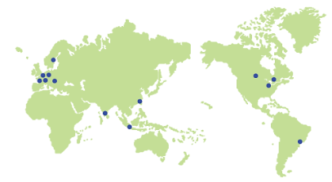
Claremont School of Theology, U.S.A
Emmanuel College of Victoria University, Canada
St. Andrew’s College, Canada
University of Redlands, U.S.A
San Fransisco Theological Seminary, U.S.A
Columbia Theological Seminary, U.S.A

Europe
Humboldt University of Berlin, Germany
University of Heidelberg, Germany
Missionsakademie an der Univ. Hamburg, Germany
Faculte libre de Theologie Protestante de Paris, France
Károlí Gáspár University of the Reformed Church in Hungary
Debrecen Reformed Theological University in Hungary
Lund University, Sweden

[Application Form]

Envisioning ecumenism, articulating prophetic spirituality

Studies in Ecumenism and Social Transformation
The Graduate School of Theology Hanshin University

STUDENT GUIDELINES & APPLICATION FORM

A. Eligibility
Foreigners (Non-Korean students whose parents are both non-Koreans, applicant and applicant’s parents must not hold Korean nationality including dual nationalities) who has a Bachelor’s Degree in Theology or higher (B.Th., M.Div., Th.M.) with a grade point average of 80/100 or higher (average letter grade of B- or higher, single-digit numerical grade 2.0 or higher)
(Citizenship status is determined at the time of application submission)

B. Application Timeline
Category | Schedule(KST)
Application and Document Submission | Oct. 2, 2025 ~ Nov. 21, 2025
Interview | Nov. 27, 2025
Admission Announcement | Dec. 2025 (TBA)
Beginning of Semester | Mar. 01, 2026
*Dates may subject to change. Any changes will be notified on the Hanshin University Seoul Campus homepage.

C. Student Guidelines
• The application form will be used solely for the purpose of applying for admission for the following academic year.
• Application forms must be completed in English. Please type or write clearly. The details you give in your application form will be used by the administration to process your application, and may serve as the basis for your student record. Incorrect information could significantly affect your permanent records.
• Carefully follow the order of the sections when filling out the information in the application form. Provide all required information, including your surname/family name, first or given name and other names that clearly identify you, consistent with all other documents submitted.
Please use only the full name given in your passport and identity documents. Supply all other information requested in the application form.
• All the date and time mentioned on the Application Guide is based on Korean Standard Time.
• Application forms must be accompanied by the supporting materials listed below. Please take note that supporting materials will not be returned once submitted.
• Application forms will be accepted from Oct 2, 2025 to Nov 21, 2025 (KST).
• Applicants must submit the application forms both through email and airmail and must arrive before Nov 21, 2025.
• If the original and email sent application forms are different or there is false entry or other illegalities in the form, the applicant will be disqualified.
• Applicant may be asked for additional supporting documents.
• Students for S.E.S.T. program (Th.M.) may receive partial or full scholarships. Please note that it covers tuition, entrance fee and dormitory fee (single room shared by two people).
• The scholarship does not cover international airfare and personal expenses. Students must prove their financial status by providing bank statement (certificate of balance) of approx. $6,000 in your name or parents.

D. Application Procedure
STEP 01 |  | STEP 02 |  | STEP 03 |  | STEP 04
Fill out Application/  Prepare documents |  | Send application, documents and application fee |  | Online Interview |  | Announcement of admission results
STEP 08 |  | STEP 07 |  | STEP 06 |  | STEP 05
Completion of admission process |  | Visa application  (Embassies and legations abroad) |  | Prepare visa documents |  | Certificate of Admission sent out

E. Required Documents
All documents must be original document and all must be submitted by the deadline.
Application form
(The statement of purpose of application and future vision after graduation must be fully expressed)
One passport-sized ID photograph (must be attached to the application form)
A certified true copy of a bachelor’s degree certificate or diploma in Christian Theology, Divinity or a closely related discipline, along with transcript of records
- Degree with apostille verification from your government must be also submitted, or notarized from the Korean Consulate if the country of your educational background is not one of the Apostille Convention joined countries.
- A copy of the apostille or notarization from the Korean Consulate should be attached on a graduation certificate issued in your original language. If your diploma is not in English or Korean, please receive a translation in English or Korean with the notarization from the notary office after getting an original apostille with the diploma in your original language and submit both.
- After submitting an online copy of the apostille document issued within six months of the application date, the original should be sent to Hanshin University by mail after acceptance.
- If graduated from a country other than where the applicant is located, the Apostille/consular certification must be obtained from the country of the school’s location.
- Original documents submitted will not be returned to the student for any reason as the school has a legal obligation to keep them permanently. Therefore, it is recommended to get an apostille/consular certification on your certified copy of diploma.
Curriculum vitae or resume listing your academic, professional and church/ecumenical experience
Two recommendation letters in sealed envelopes, in addition to the finalized admission application form
- One letter from immediate superior, such as Presbytery Moderator, Conference Minister, Department Head or Dean of School
- One letter from a church national office, such as the General Secretary, Chairperson of Ministry Committee or Scholarship Committee
Copy of valid passport
Balance certificate
- Personal bank balance certificate with at least USD 6,000 maintain minimum balance must be maintained.
- As immigration policies have been strengthened, students must submit the balance certificate issued within 30 days of the visa application date. Therefore, please submit the most recently issued bank statement as of the student's application date. Additional balance certificate with updated issuance dates may be requested in the future.
- If the document is in a foreign language other than English attach an English or Korean copy that is translated and notarized by a translator or translation agency.
- Family certificate (Birth certificate) should be submitted if the account is under the name of parents
- The financial statement proving the balance of assets such as stocks, bonds, equities is not allowed.
- The bank statement should show at least USD 6,000 in one savings account.
TOEFL (IELTS, CEFR, TEPS) scores are required of applicants for the following countries
Ghana, Nigeria, Nepal, Mongol, Myanmar, Bangladesh, Vietnam, Sri Lanka, Uzbekistan, Ukraine, Iran, Egypt, India, Indonesia, China, Kazakhstan, Kyrgyzstan, Thailand, Pakistan, Peru, Philippine, Guinea, Mali, Ethiopia, Uganda, Cameroon
The minimum acceptable TOEFL score is 71 on the internet-based test (530 on the paper-based test, 197 on the computer-based test). (IELTS 5.5 or above, CEFR B2 or above, TEPS 601 or above, New TEPS 327 or above)
Please mail the TOEFL official score report to Hanshin University Graduate School of The Theology. TOEFL scores are valid for two years after the test date.
Health certificate which includes X-ray and hepatitis B test results.
Measles vaccination certificate (certificate must confirm that you have received the vaccination twice)
Complete the “Inquiry into Academic Record” and “Letter of Consent” forms to verify your graduation.
Letter of Assurance for Financial Support

E. VISA Application
[Visa Application Process]
School |  | Applicant |  | Consular |  | Consular |  | Applicant
Provide certificate of admission, scholarship and etc. |  | Submit application document |  | Reception and Review  (overseas diplomatic office) |  | Visa issuance  (overseas diplomatic office) |  | Entry to Republic of Korea

[VISA Application Required Documents]
- Application, copy of passport, one photo, fee
- Document issued by Hanshin University (certificate of admission, business registration, etc.)
- Academic Documents(Degree Certificate) and balance certificate
- Tuberculosis medical certificate issued by a diagnostic hospital designated by the diplomatic office (for students from below countries)
China, Sri Lanka, Russia (federation), Uzbekistan, Thailand, Vietnam, India, Nepal, Indonesia, Pakistan, Mongolia, Bangladesh, Philippines, Myanmar, Cambodia, Malaysia, East Timor, Kyrgyzstan, Laos, Kazakhstan, Tajikistan, Ukraine, Azerbaijan, Belarus, Moldova, Nigeria, South Africa, Ethiopia, Democratic Republic of the Congo, Kenya, Mozambique, Zimbabwe, Angola, Peru, Papua New Guinea
- Other documents may be requested by the diplomatic office
- Please contact the diplomatic office consulate of country of residence (jurisdiction) for detailed information

The nonrefundable application fee of USD 50 should be wired to our school account as indicated below.
Your application will be considered complete once the application fee has been received until Nov 21, 2025, to the following account: Bank Name: Kookmin Bank / Bank Account: 203901-04-254757 / SWIFT Code: CZNBKRSEXXX

All the original documents must be written in English and should be sent
until Nov 21, 2025 to the following address and email:
(When sending the documents by airmail, please send them first in PDF format via email)

Graduate School of Theology, Hanshin University
159 Insubong-ro, Gangbuk-gu, Seoul, Republic of Korea, 01025

E-mail: oikoumene@hs.ac.kr

Interview is expected Nov 27, 2025(Korea Standard Time).

Admitted applicants will be posted on our homepage and notified by email on Dec. 2025.
.

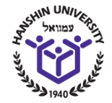

Passport size photo (4x5cm)

STUDENT APPLICATION FORM

Program of Study
Academic Term | Spring 2026 –Fall 2027 | Registration No. | (for office use, do not fill-in)
Applicant’s Qualifications  for Th. M. | Qualified overseas/foreign applicants are those whose both parents are non-Korean citizens and himself/herself a citizen of a country other than Republic of Korea. Must have completed basic education (elementary, middle school, high school) and acquired Bachelor of Theology degree (B.Th.) in Theology accredited by the government.
Major | Theology  (Studies in Ecumenism and Social Transformation) | Type of Application | Th. M.
Certification and Credit Audit | Open to all
1. Personal Information
Title:  (Mr., Ms., Rev., etc.) | Family/Surname:  (as in passport)
First/Given Name (s)
(as in passport)
Gender: __Female __ Male | Civil status __ _Single __Married  ____Other (please specify)
Date of Birth:  (MM-DD-YYYY) | Place of Birth:  (city, country)
Country of Birth:  (as in passport) | Nationality:  (as in passport)
Passport Number: | Place of Issue:
Date of Issue:  (MM-DD-YYYY) | Valid Until:  (MM-DD-YYYY)
Church Affiliation:
(full name of the national church/diocese/denomination)

2. Family Information
Spouse’s Family/Surname:  (before marriage) | Spouse’s First/Given Name(s)
Father’s Family / Surname: | Father’s First/Given Name(s):
Mother’s Family /Surname: | Mother’s First/Given Name(s):

Personal Information

3. Contact Information
Street Address:

Post/Zip Code: | City:
State/Province: | Country:
Telephone:  (country code, area code, #) | Fax:  (country code, area code #)
E-mail Address: | Alternative E-mail Address:
4. Scholarship : Fill in, only if applicable
Support of Religious body:

Education
 | Name of School or Educational Institution | City and country of issue | Inclusive dates of attendance | Obtained degree
Master’s Degree
Bachelor’s Degree

Language
Note: English is the language of both instruction and interaction at the program of Studies in Ecumenism and Social Transformation
Mother Tongue/Language:
For other languages enter the appropriate number from code below to indicate level of your language knowledge and proficiency.
Code: 0 = No skills; 1 = Limited conversation, reading of simple documents, routine correspondence.
2 = Engage freely in discussion, read and write more difficult material.
3 = Speak, read and write (nearly) as in mother tongue/native language
Language | Speaking | Reading | Writing

Other Information
Current Profession/Job:

Ecumenical Experience(Need to be fully illustrated):

Other information that the admission department should take into account in considering your application.

How did you find out about the program for Studies in Ecumenism and Social Transformation?

I testify that information I have given in this form is true and accurate and that, if admitted,
I agree to abide by the conditions governing the Graduate School of Theology, Hanshin University.
Date: (MM-DD-YYYY) | Signature:

The nonrefundable application fee of USD 50 should be wired to our school account as below.
Your application will be complete when you finally send us the application fee until Nov 21st, 2025 (KST)
Bank Name: Kookmin Bank / Bank Account: 203901-04-254757 / SWIFT Code: CZNBKRSEXXX
Statement of Purpose

Name of Applicant: __________________________ Major: _______________________

Category | Contents  Full and concise description of your Statement of Purpose, knowledge  about the major course and career path after graduation.
Statement of Purpose:
Reasons of applying for
the academic program
for S.E.S.T.
Knowledge about the Major:
Initial learning,
understanding and
experiences of the course
you will be taking.
Career path:
What you intend to do
after graduation.

Use separate paper if needed.

LETTER OF INQUIRY INTO ACADEMIC RECORD

Date: 2025. . .
School Name: (official school name)
School Address: (Dpt.)

Zip code: Tel: Fax:
E-mail: (person in charge of academic background)
Student Name: (registered in the school)
Student Id Number: (registered in the school)

Subject: Requesting Student Information

Dear. Sir / Madam
The above applicant has submitted educational documents issued by your institution to our university. We request you to verify the accuracy and authenticity of the copies of the enclosed documents. We need your confirmation about his/her graduation, major field, and the date of graduation. Kindly complete the below and return to our office. You can respond via fax or mail. Thank you for your cooperation. We look forward to hearing from you soon.

Sincerely,

Questions to verify student information. (Applicants should not fill out the form below)

Student's name:
Degree:
Major:
Date conferred:
Name of institution:
Signature of University official:
Fax: Email:

LETTER OF CONSENT

To whom it may concern,

This letter is to confirm that I attended (Name of University)

I have applied to Graduate School of Theology, Hanshin University in Seoul, Korea for the 2025 academic year and have agreed to allow attended
University to officially request my academic records from previously attended schools.

In this regard, I would like to request your full assistance when they contact you regarding verification of enrollment and transcripts.

Enrolled Name:
Student ID Number:
Date of Birth:
Date of Admission (transfer):
Date of Graduation (withdrawal):

Sincerely yours,
Signature

Date:
2025. . .

Letter of Assurance for Financial Support

Applicant's Name | Family/Surname:  First/Given Name:  (as in passport)
I hereby assure that I will support the applicant (Your name) financially for managing the airfares from the home country to Seoul, Korea and from Seoul back to the home country and living expenses while s/he enrolls the two-year academic program of Studies in Ecumenism and Social Transformation as follows:

Please fill out the part you will support:

Content Amount (USD)
- Cost of international airfare
- Personal stipend and other needs
Total

Please use one for each supporter

Name of Person /Church/Organization: |  | Signature:



Campus Map

Entrance
Chapel
Cafeteria
Main Building
Library
Baeksoek Building
Dormitory

Directions to University

- Take the subway #4 line.Get off at Su-Yu station and exit through exit no. 3 Take local bus (maeul bus) #2Get off at the Graduate School of Theology, Hanshin University
- Take subway #UI lineGet off at Hwagye station and exit through exit no. 2Walk up to the Hanshin University
By Subway




By Bus
Take bus #109, #151 or #1165 Get off at the Graduate School of Theology, Hanshin University
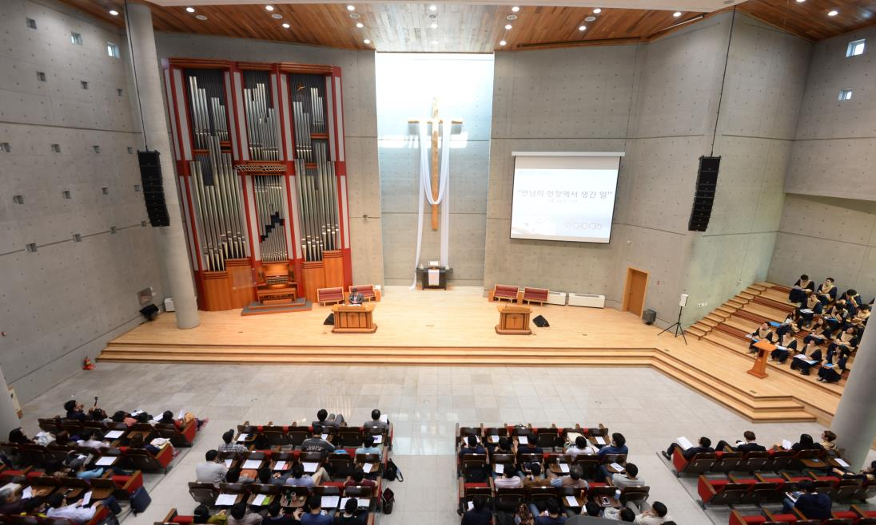

159 Insubong-ro, Gangbuk-gu, Seoul, Republic of Korea, 01025
Phone. 82-2-2125-0108 Fax. 82-2-902-3055
http://www.hs.ac.kr/gsth/8417/subview.do
E-mail: oikoumene@hs.ac.kr

